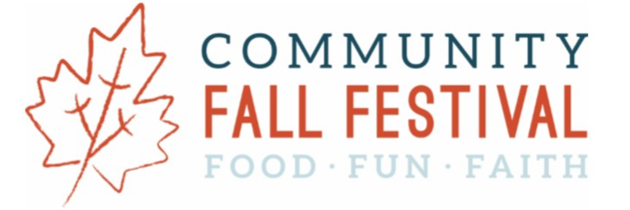

Items needed!

- Lend a Canopy (please please!)
https://www.signupgenius.com/go/30E0D4FABA829ABF85-65041206-lend

House Plants

Donate house plants for the Fall Festival Plant Sale! For more information call Fran Petras at 443-388-1867.

Support St. Vincent de Paul Food Pantry

Please consider donating an item or two for the SVdP Food Pantry—we’ll have shopping carts for your donations! Items to consider: peanut butter, pancake mix and syrup, canned vegetables, canned chicken, condiments, soup, cake mixes and frosting, laundry/dish detergent, toothpaste.

Scarecrow Making

We need adult female and male jeans, overalls, and long-sleeved button-up shirts for kids to make scarecrows at the Festival. Items may be dropped off at the Pastoral Center at Resurrection. Please label: Scarecrow
Please: no leggings, shorts, or children’s clothing.

Silent Auction Items

The Fall Festival’s Silent Auction committee is looking for one-of-a-kind items and experiences. We are asking for your generous donation of:
- Stays at beach houses, mountain cabins, or other relaxing locales
- Tickets to sporting, music, and cultural events
- Other experiences for groups of friends and families (for example: complete crab feasts, wine/bourbon/whiskey tastings, charcuterie boards, bull & oyster roasts)
- Gift cards from your favorite local restaurants, inns, spas, wineries, brewpubs and shops
- Sports memorabilia
Yeti coolers
Scout, Bogg, or Vera Bradley totes and bags
Scratch-off lottery tickets
Non-alcoholic canned beverages (“mocktails”)

If you are not sure if your donation can be used, please feel free to contact one of the Silent Auction co-chairs, Sara Thomas or Andrea Wills (andreaewills@gmail.com, sscheanwald@mac.com)

​

